Shashwat Pandey

Failure prediction in machines using Ensemble learning and TElemetry analysis

Improving Reliability and Reducing Downtime in Industrial Systems through Predictive Analytics.

**Model Accuracy Analysis**

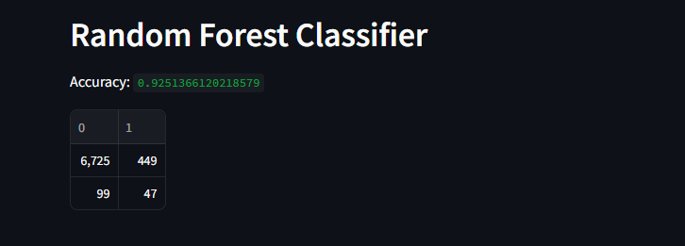

**High Accuracy is Misleading**

The model achieved 92.5% accuracy primarily by correctly predicting the dominant class (class 0).

This makes accuracy a poor metric in this case.

**Poor Detection of Class 1 (Minority Class)**

Precision: Only 9.4% of class 1 predictions are correct.

Recall: Misses about 68% of actual class 1 samples.

F1 Score is very low (0.145), indicating poor balance between precision and recall.

**Severe Class Imbalance**

Class 0 dominates the dataset (98%), so the model is biased toward predicting class 0.

This imbalance results in underfitting for class 1.

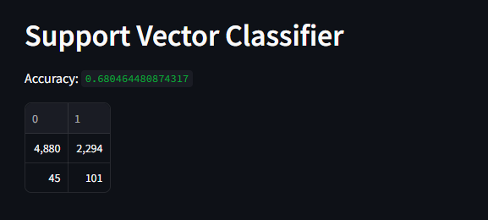

While this is a significant drop from the Random Forest accuracy (92.5%), we’ll see why this model might actually be better at handling the minority class, which is often more important in real-world applications.

**Lower Accuracy, But Better Recall for Class 1**

The **recall for class 1 (minority)** has improved **from 32.1% (RF) to 69.2% (SVC)**.

This means the SVC model identifies **more of the true class 1 cases**—which is **crucial in applications like fraud detection, disease diagnosis**, etc.

**Poor Precision for Class 1**

Only **4.2%** of the predictions for class 1 were correct — this indicates **a large number of false positives**.

Model is more "liberal" in predicting class 1 to **capture as many true positives as possible**.

**Model Trade-off: Recall vs Precision**

SVC trades **precision for higher recall**.

This trade-off may be **desirable or unacceptable depending on context**:

In **medical** scenarios, high recall is preferred (to catch every case).

In **spam filters**, false positives are annoying — so high precision is needed.

**Still Affected by Class Imbalance**

Like with Random Forest, the performance is still skewed by the **imbalanced class ratio**.

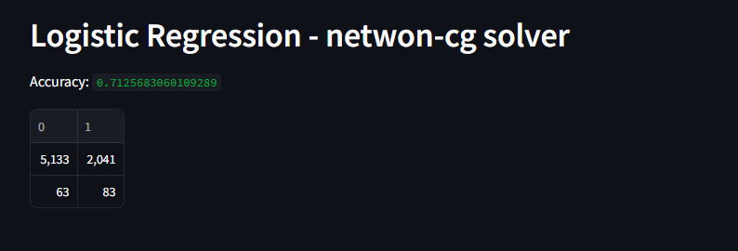

**Balanced Trade-off**

**Compared to SVC**, Logistic Regression shows:

**Slightly lower recall** for class 1 (56.8% vs. 69.2%)

**Fewer false positives**, improving **precision** slightly (~4%)

**Higher accuracy** (71.2% vs. 68%)

**Still Poor Precision for Minority Class**

As with SVC, a lot of class 0 samples are being misclassified as class 1 (2041 FPs), leading to a **very low precision (3.9%)**.

This means many alarms raised by the model for class 1 are **false**.

**Class Imbalance Continues to Hurt Precision**

The classifier tries to improve recall on class 1 by **predicting more positives**, but this increases **false positives**.

This results in a **low F1 score (0.074)** for class 1, despite a decent recall.

**ENSEMBLE MODEL**

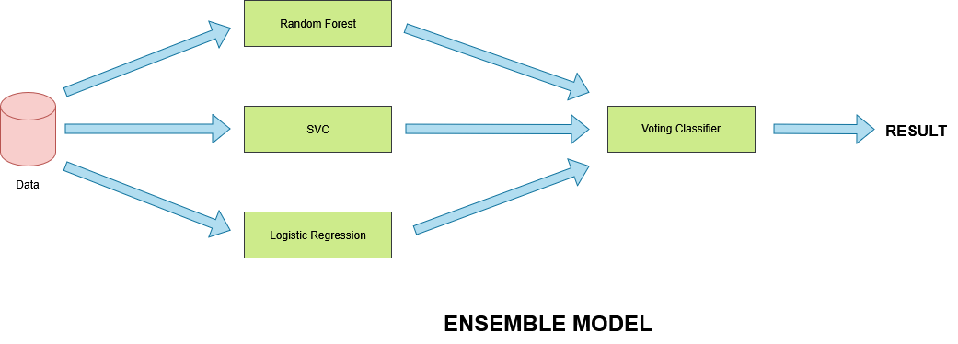

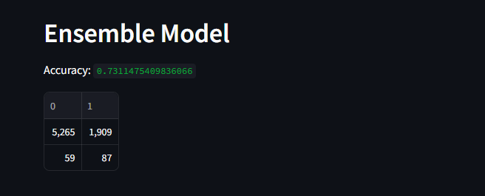

This model delivers a strong recall (59.6%) for the minority class while maintaining a moderate level of false positives. Accuracy is highest among non-RF models (73.11%). Class 0 performance remains robust

But compared to other models, it provides the most balanced recall–precision trade-off so far.

The ensemble model smooths out **overfitting** and **underfitting tendencies** of base learners.

The **Ensemble Model** is currently the **best-balanced model** after Random Forest:

* It handles both accuracy and recall well.
* With tuning, it could be **the optimal model for deployment**, especially if interpretability and
* stability are required.